Notice to SDA provider
Residential Tenancies Act 1997 (the Act)
SDA residents may use this form to give notice to the SDA provider:
- requesting to install fixtures
- seeking non-urgent repairs
- seeking urgent repairs
- regarding their intent to vacate the dwelling.

How to use this form
- Complete all parts of the form.
- Identify your reason for giving this notice in part 4. Select the reason that fits your circumstances. If you are vacating, write the date that you intend to leave.
- You must provide evidence or receipts for certain reasons. If you are providing them, attach them to the notice and circle ‘Yes’ in part 5.
- Sign the form at part 6.
- Send a completed copy of the form to your SDA provider.
- Keep copies of the completed form. If your SDA provider does not comply, you can post a copy to Consumer Affairs Victoria to request an inspection, or email the document to renting@justice.vic.gov.au.

How to serve this notice
You can serve this notice by hand, or by post, or by email (with consent).
If you send this notice by post, you must take into account the extra days it takes for the notice to be delivered. Australia Post has three different speeds for ordinary mail delivery – express, priority and regular mail, which may take up to six days. Priority and regular delivery speeds also apply for registered post. You may wish to keep evidence of the mail delivery method you relied on to send this notice. For more information about Australia Post’s mail delivery options and times, visit the Australia Post website (auspost.com.au).
You can only send this notice by email if you already have the SDA provider’s written consent to receive notices and other documents this way. The SDA provider may have given consent in the SDA residency agreement or separately in writing. A consent form is available from the Forms and publications section – Consumer Affairs Victoria website (consumer.vic.gov.au/forms).
If you send this notice by email, the provisions of the Electronic Transactions (Victoria) Act 2000 apply. For legal purposes, the time when a notice is received is when it can be retrieved from the email address the recipient nominated.
To help calculate the total minimum days to allow, depending on the notice period required and the method of delivery, visit the Giving notices – Residential Tenancies List page – Victorian Civil and Administrative Tribunal website (vcat.vic.gov.au/resources/giving-notices-residential-tenancies-list).

Assistance
If you need help with this notice, visit the Specialist disability accommodation section – Consumer Affairs Victoria website (consumer.vic.gov.au/sda) or for more information about specialist disability accommodation, call Consumer Affairs Victoria on 1300 40 43 19.

Telephone Interpreter Service
If you have difficulty understanding English, contact the Translating and Interpreting Service (TIS) on 131 450 (for the cost of a local call) and ask to be put through to an Information Officer at Consumer Affairs Victoria on
1300 55 81 81.
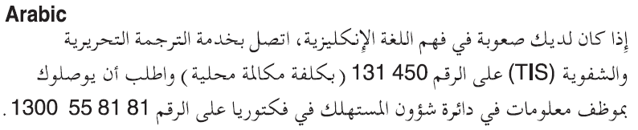
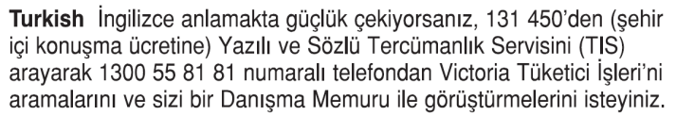
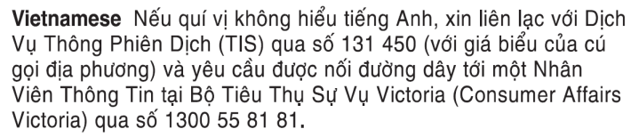
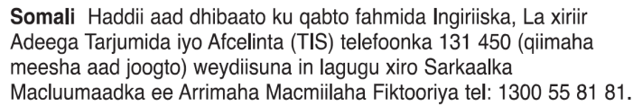
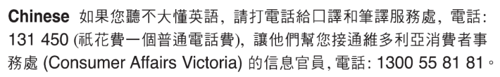
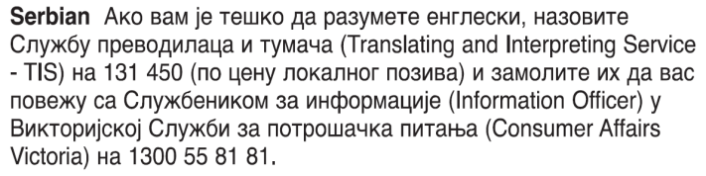
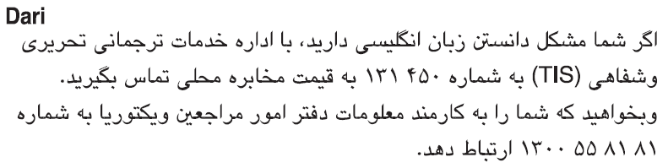
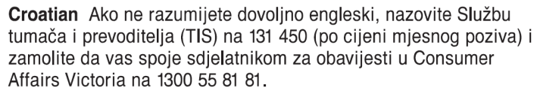
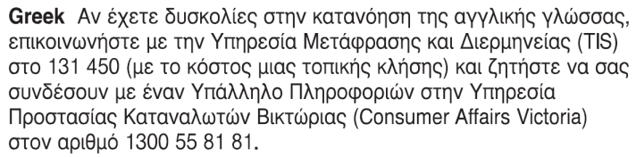
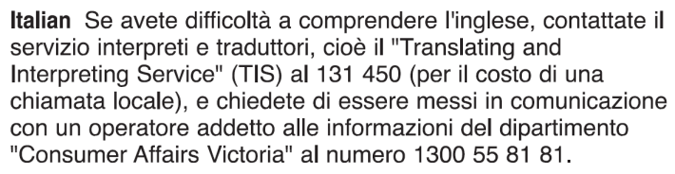
Information about renting is available in other languages at consumer.vic.gov.au/languages.

Notice to SDA provider
1. SDA provider details
This notice is given to:
(SDA provider’s name)
SDA provider’s address:

2. SDA resident details
Resident’s name:
Regarding the SDA enrolled dwelling at:
(write address)
Address for serving documents:
(if the same as in 4, write ‘as above’)
SDA resident’s contact telephone numbers
Business hours:
After hours:

3. Service details
This notice is given:
(mark one method only and if posted note the delivery speed)
By hand:
By registered post:
By ordinary post:
By email:
Insert email address:
(if applicable)
On:  (dd/mm/yyyy) | / /

4. Notice
I am giving you notice of the following:
(Residents should select the correct reason and include further details in the box below)

498N Request to install fixtures
I am seeking your consent to install the following fixtures:
Fixture | Location | Details
Fixture 1
Fixture 2
Fixture 3

498Q Non-urgent repairs
The dwelling needs the following non-urgent repairs:
Repair | Details

498P Urgent repairs
The dwelling needs the following urgent repairs:
Repair | Details

498ZZA Intention to vacate
I am giving you written notice that I intend to vacate the SDA enrolled dwelling on:
Date:  (dd/mm/yyyy) | / /

5. Reasons
(you may include further details about the reasons here)
Have you attached other documents as evidence?
Yes / No

6. Resident’s signature

