Notice of withdrawal to SDA resident
Residential Tenancies Act 1997, Part 12A
Specialist Disability Accommodation
Sections 498ZZB

Note:
Use this form if you are a specialist disability accommodation (SDA) provider; you have previously provided the SDA resident with a notice of temporary relocation or notice to vacate and wish to withdraw that notice.
You must give details of this notice to the Director of Consumer Affairs Victoria within 14 days of the notice being given. To notify us, visit consumer.vic.gov.au/SDAnotify.
Enter text in spaces provided only.
This document is available for download at consumer.vic.gov.au/forms.

How to use this form
- Complete all the questions
The form must be given to the same person who was given the notice that is being withdrawn.
- Sign at 10 and enter the date at 12.
The form must be signed by the same person who gave the notice that is being withdrawn.

How to serve this notice
The notice must be given by post, or by delivering it personally to the resident between 8am and 6pm, or by email (with consent).
You must also explain the notice in a language, mode of communication and terms the resident is likely to understand. If it will help the resident, you must explain it verbally and in writing.
You must give a copy of the notice to the resident’s guardian or administrator, if any.
If it will help the resident, you must also give a copy of the notice to the resident’s family member, carer, advocate or other chosen person.
If the resident has not chosen a support person, you can choose a person who is not your employee or representative to assist the resident.
You can only give this notice by email if you already have the resident’s written consent to receive notices and other documents this way.
You and the resident may have consented to electronic service of notices and other documents in the SDA residency agreement.

Telephone Interpreter Service
If you have difficulty understanding English, contact the Translating and Interpreting Service (TIS) on 131 450 (for the cost of a local call) and ask to be put through to an Information Officer at Consumer Affairs Victoria on
1300 55 81 81.
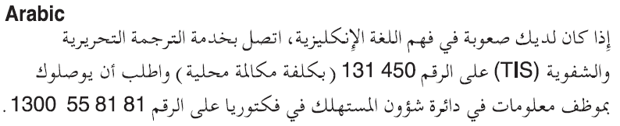
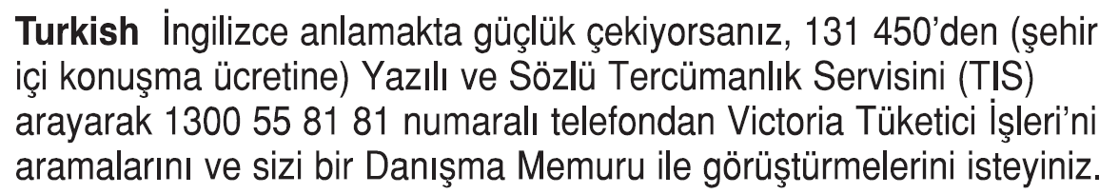
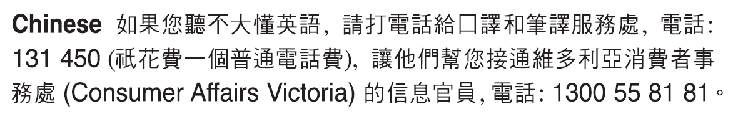
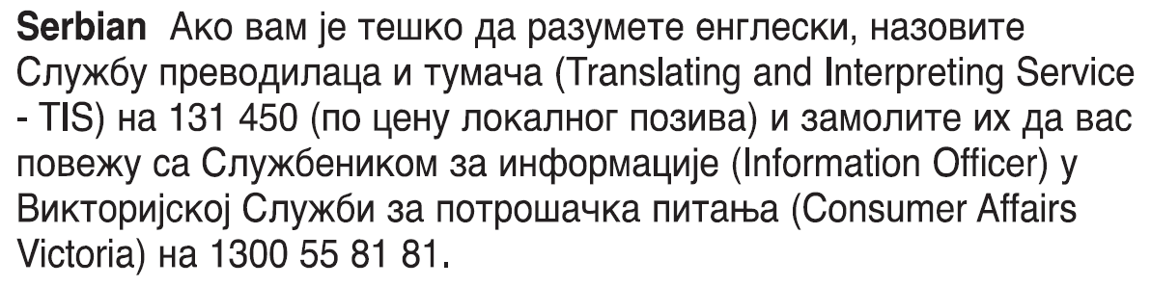
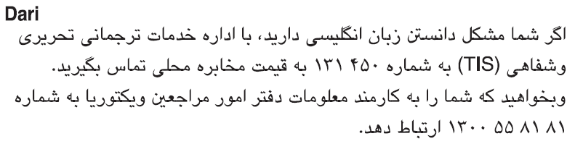
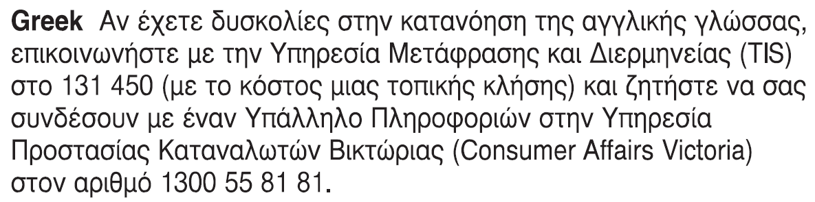
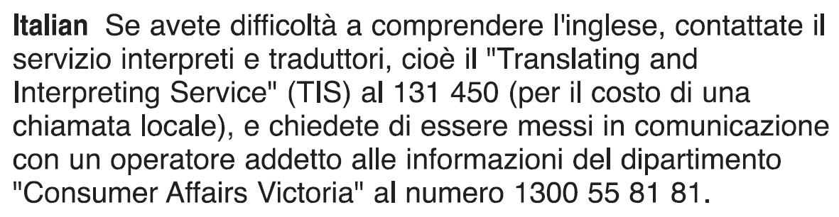 Information about renting is available in other languages at consumer.vic.gov.au/languages.

Notice of withdrawal to SDA resident SDA resident’s copy
Residential Tenancies Act 1997 s498ZZB

SDA resident details
- This notice is given to:
(resident/s name)
- A copy of this notice is also given to:
(if applicable, insert name and address of resident’s family member, carer, advocate, guardian, administrator or other chosen person)
- Regarding the SDA dwelling at:
(write address)
- Resident’s address:

SDA provider/mortgagee/owner details
- I am giving you this notice as:
(mark one only)
The SDA provider:
The mortgagee:
The owner:
- SDA provider/mortgagee/owner name:
(cannot be agent’s name)
- SDA provider/mortgagee/owner address for serving documents:
(can be an agent’s address)
- Contact telephone numbers for SDA provider/mortgagee/owner:
(can be agent’s telephone number)
Business hours:
After hours:

Withdrawal of notice
- On:
(dd/mm/yyyy)
/ /
I gave you the following notice:
□ Notice of temporary relocation
□ Notice to vacate
- I am withdrawing the notice described at 9.
- Signature of SDA provider, their authorised officer or agent:
Name of SDA provider, their authorised officer or agent signing this notice:
- Date:
(dd/mm/yyy)
/ /

Notice of withdrawal to SDA resident SDA residents support person’s copy
Residential Tenancies Act 1997 s498ZZB

SDA resident details
- This notice is given to:
(resident/s name)
- A copy of this notice is also given to:
(if applicable, insert name and address of resident’s family member, carer, advocate, guardian, administrator or other chosen person)
- Regarding the SDA dwelling at:
(write address)
- Resident’s address:

SDA provider/mortgagee/owner details
- I am giving you this notice as:
(mark one only)
The SDA provider:
The mortgagee:
The owner:
- SDA provider/mortgagee/owner name:
(cannot be agent’s name)
- SDA provider/mortgagee/owner address for serving documents:
(can be an agent’s address)
- Contact telephone numbers for SDA provider/mortgagee/owner:
(can be agent’s telephone number)
Business hours:
After hours:

Withdrawal of notice
- On:
(dd/mm/yyyy)
/ /
I gave you the following notice:
□ Notice of temporary relocation
□ Notice to vacate
- I am withdrawing the notice described at 9.
- Signature of SDA provider, their authorised officer or agent:
Name of SDA provider, their authorised officer or agent signing this notice:
- Date:
(dd/mm/yyy)
/ /

Notice of withdrawal to SDA resident SDA provider’s copy
Residential Tenancies Act 1997 s498ZZB

SDA resident details
- This notice is given to:
(resident/s name)
- A copy of this notice is also given to:
(if applicable, insert name and address of resident’s family member, carer, advocate, guardian, administrator or other chosen person)
- Regarding the SDA dwelling at:
(write address)
- Resident’s address:

SDA provider/mortgagee/owner details
- I am giving you this notice as:
(mark one only)
The SDA provider:
The mortgagee:
The owner:
- SDA provider/mortgagee/owner name:
(cannot be agent’s name)
- SDA provider/mortgagee/owner address for serving documents:
(can be an agent’s address)
- Contact telephone numbers for SDA provider/mortgagee/owner:
(can be agent’s telephone number)
Business hours:
After hours:

Withdrawal of notice
- On:
(dd/mm/yyyy)
/ /
I gave you the following notice:
□ Notice of temporary relocation
□ Notice to vacate
- I am withdrawing the notice described at 9.
- Signature of SDA provider, their authorised officer or agent:
Name of SDA provider, their authorised officer or agent signing this notice:
- Date:
(dd/mm/yyy)
/ /

