Breach of duty notice to SDA resident
Residential Tenancies Act 1997 (the Act), Part 12A
Specialist Disability Accommodation
Section 498ZP
Note:
Use this form if you are a Specialist Disability Accommodation (SDA) provider and you are issuing a breach of duty notice to the SDA resident (the resident) for:
- creating a fire, health or safety hazard
- failure to pay for repairs to damage caused by the resident
- failure to pay rent
- damaging or destroying any part of dwelling
- installing fixtures without consent
- keeping a pet without consent
- failure to permit entry.
This form must be provided to both the Specialist Disability Accommodation (SDA) resident and the resident’s guardian or administrator, if any.
Enter text in spaces provided only.
This document is available for download at consumer.vic.gov.au/forms.
How to use this form
- Identify your reason for providing a breach of duty notice
Read the reasons on page 3. These are the breaches of duty listed in the Act under which you can give a breach of duty notice.
Select the correct reason and write down the section number.
- Complete questions 1 to 10
You must complete all boxes.
- Sign at 11

How to serve this notice
The notice must be given by post, or by delivering it personally to the resident between 8am and 6pm, or by email (with consent).
You must give a copy of the notice to the resident’s guardian or administrator, if any.
You must also explain the notice in a language, mode of communication and terms the resident is likely to understand. If it will help the resident, you must explain it verbally and in writing.
If it will help the resident, you must also give a copy of the notice to the resident’s family member, carer, advocate or other chosen support person.
If the resident has not chosen a support person, you can choose a person who is not your employee or representative to assist the resident.
You can only give this notice by email if you already have the resident’s written consent to receive notices and other documents this way.
You and the resident may have consented to electronic service of notices and other documents in the SDA residency agreement.

Telephone Interpreter Service
If you have difficulty understanding English, contact the Translating and Interpreting Service (TIS) on 131 450 (for the cost of a local call) and ask to be put through to an Information Officer at Consumer Affairs Victoria on
1300 55 81 81.
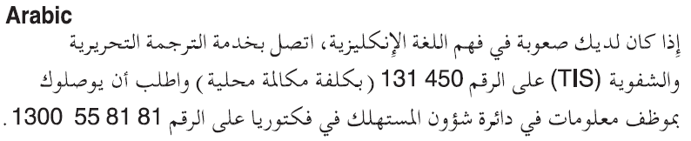
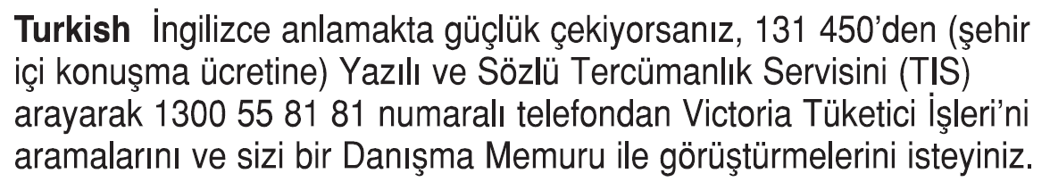
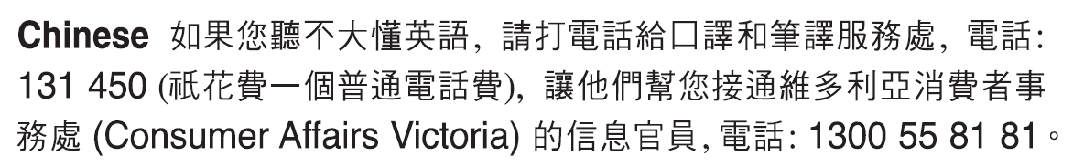
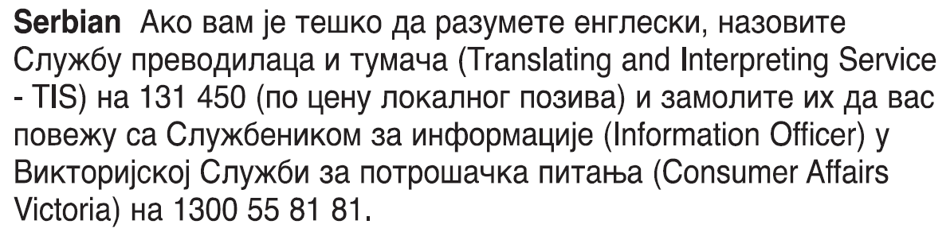
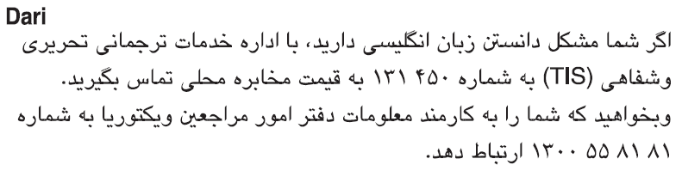
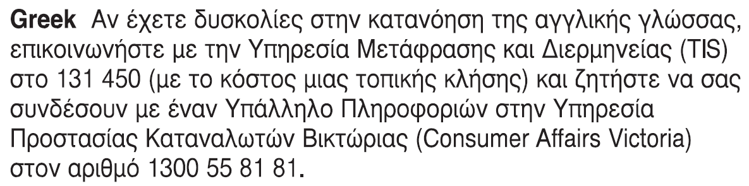
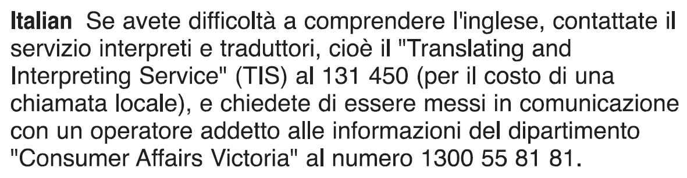
Information about renting is available in other languages at consumer.vic.gov.au/languages.

Breach of duty notice to SDA resident

Reasons for giving breach of duty notice
Reason and section number | Detail
Creating a fire, health or safety hazard  498N(1)(a) | You have failed to maintain the dwelling in a manner that does not create a hazard.
Failure to pay for damage  498N(1)(c) | You have not contributed to the cost of repairing damage that you caused to the dwelling.
Failure to pay rent  498N(1)(d) | You have not paid rent on the due date or in the correct manner.
Damage or destruction  498N(2)(d) | You have damaged or destroyed part of the dwelling.
Installation of fixtures  498N(2)(e) | You have installed fixtures in the dwelling without obtaining the written consent of the SDA provider.
Keeping a pet without consent  498N(2)(f) | You have kept a pet in the dwelling without first obtaining the consent of the SDA provider.
Failure to permit entry  498Y | You have not permitted a person exercising a right of entry to enter the dwelling.

Breach of duty notice SDA resident’s copy
Residential Tenancies Act 1997 S498ZP

SDA resident details
- This notice is given to:
(resident/s name)
- A copy of this notice is also given to:
(if applicable, insert name and address of resident’s family member, carer, advocate, guardian, administrator or other chosen person)
- Regarding the SDA enrolled dwelling at:
(write address)
- Resident’s address:
(if same address as in number 3, write ‘as above’)

SDA provider details
- I am giving you this notice as the:
(select one only)
SDA provider □
SDA owner □
- SDA provider/owner name:
(cannot be agent’s name)
- SDA provider/owner address for serving documents:
(can be an agent’s address)
- Contact telephone numbers for SDA provider/owner:
(can be agent’s telephone number)
Business hours:
After hours:

Service details
This notice is given:
(mark one method only and if posted, note the delivery speed)
By hand:
By registered post:
By ordinary post:
By email:
Insert email address:
(if applicable)
On:  (dd/mm/yyyy) | / /

Reason for breach of duty notice
- You have breached your duty as resident because:
(write the relevant section number and words from page three)
The loss or damage (if any) caused is:
Section 9 continues next page

Section 9 continued
Compensation or compliance required:
I require you to remedy the breach within 14 days after receiving this notice by:
or pay me compensation of:
($)
You must not commit a similar breach again. If you do not comply with this notice I may apply to the Victorian Civil and Administrative Tribunal (VCAT) for a compensation or compliance order, or I may give a notice to vacate under section 498ZX.
- Details are attached to this notice:
(for example, receipts, other evidence)
Yes:
No:
- Signature of SDA provider/owner, their authorised officer or agent:

Breach of duty notice SDA residents support person’s copy
Residential Tenancies Act 1997 S498ZP

SDA resident details
- This notice is given to:
(resident/s name)
- A copy of this notice is also given to:
(if applicable, insert name and address of resident’s family member, carer, advocate, guardian, administrator or other chosen person)
- Regarding the SDA enrolled dwelling at:
(write address)
- Resident’s address:
(if same address as in number 3, write ‘as above’)

SDA provider details
- I am giving you this notice as the:
(select one only)
SDA provider □
SDA owner □
- SDA provider/owner name:
(cannot be agent’s name)
- SDA provider/owner address for serving documents:
(can be an agent’s address)
- Contact telephone numbers for SDA provider/owner:
(can be agent’s telephone number)
Business hours:
After hours:

Service details
This notice is given:
(mark one method only and if posted, note the delivery speed)
By hand:
By registered post:
By ordinary post:
By email:
Insert email address:
(if applicable)
On:  (dd/mm/yyyy) | / /

Reason for breach of duty notice
- You have breached your duty as resident because:
(write the relevant section number and words from page three)
The loss or damage (if any) caused is:
Section 9 continues next page

Section 9 continued
Compensation or compliance required:
I require you to remedy the breach within 14 days after receiving this notice by:
or pay me compensation of:
($)
You must not commit a similar breach again. If you do not comply with this notice I may apply to the Victorian Civil and Administrative Tribunal (VCAT) for a compensation or compliance order, or I may give a notice to vacate under section 498ZX.
- Details are attached to this notice:
(for example, receipts, other evidence)
Yes:
No:
- Signature of SDA provider/owner, their authorised officer or agent:

Breach of duty notice SDA provider’s copy
Residential Tenancies Act 1997 S498ZP

SDA resident details
- This notice is given to:
(resident/s name)
- A copy of this notice is also given to:
(if applicable, insert name and address of resident’s family member, carer, advocate, guardian, administrator or other chosen person)
- Regarding the SDA enrolled dwelling at:
(write address)
- Resident’s address:
(if same address as in number 3, write ‘as above’)

SDA provider details
- I am giving you this notice as the:
(select one only)
SDA provider □
SDA owner □
- SDA provider/owner name:
(cannot be agent’s name)
- SDA provider/owner address for serving documents:
(can be an agent’s address)
- Contact telephone numbers for SDA provider/owner:
(can be agent’s telephone number)
Business hours:
After hours:

Service details
This notice is given:
(mark one method only and if posted, note the delivery speed)
By hand:
By registered post:
By ordinary post:
By email:
Insert email address:
(if applicable)
On:  (dd/mm/yyyy) | / /

Reason for breach of duty notice
- You have breached your duty as resident because:
(write the relevant section number and words from page three)
The loss or damage (if any) caused is:
Section 9 continues next page

Section 9 continued
Compensation or compliance required:
I require you to remedy the breach within 14 days after receiving this notice by:
or pay me compensation of:
($)
You must not commit a similar breach again. If you do not comply with this notice I may apply to the Victorian Civil and Administrative Tribunal (VCAT) for a compensation or compliance order, or I may give a notice to vacate under section 498ZX.
- Details are attached to this notice:
(for example, receipts, other evidence)
Yes:
No:
- Signature of SDA provider/owner, their authorised officer or agent:

